**App Name:** Gamebook

**Task:** “Select Favorit Team game”, “View game players” and “View team game score”

**Student Name (Expert):** Edgar Caruço

**Nielsen Heuristic:** H6. Recognition rather than recall

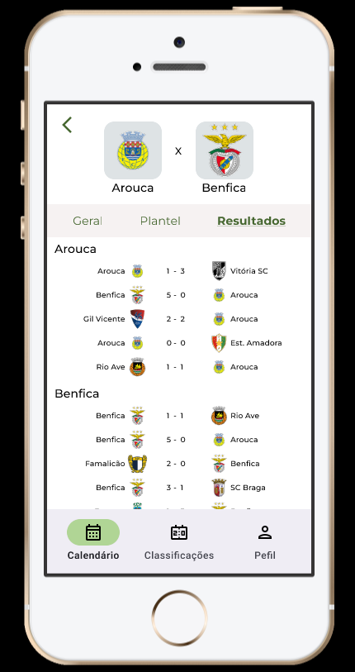

**Problem:** Club games results are only accessible on Calendar

**Heuristic:** H6. Recognition rather than recall

**Description:** Club games results are only accessible from “Calendário”, they should also be available from “Classificações”

**Correction:** Create a link from “Classificações” to “Resultados”

**Severity:** 2 - Minor usability problem